**Experiment-2.1**

**Student Name: Nabha Varshney UID: 20BCS4995**

**Branch: CSE Section/Group: 20BCS_DM_704/A**

**Semester: 6th Date of Performance: 03/04/2023**

**Subject Name: MAD LAB Subject Code: 20CSP-356**

**Aim:** Create an Android app using various controls such as TextEdit, CheckBox, RadioButton, RadioGroups, etc.

**Objective:** Android app using various controls such as TextEdit, CheckBox, RadioButton, RadioGroups, etc.

CheckBox belongs to android.widget.CheckBox class. Android CheckBox class is the subclass of CompoundButton class. It is generally used in a place where user can select one or more than choices from a given list of choices. For example, selecting hobbies.

*public class* CheckBox *extends*CompoundButton

**class Hierarchy :**

java.lang.Object

   ↳  android.view.View

        ↳  android.widget.TextView

             ↳  android.widget.Button

                  ↳  android.widget.CompoundButton

                       ↳  android.widget.CheckBox

it has two states – **checked** or **unchecked**.

**Methods of CheckBox class**

·         ***public boolean isChecked():*** If CheckBox is in checked state then return true otherwise false.

·         ***public void setChecked(boolean status):*** It changes the state of the CheckBox.

Below is the code for an example where the user chooses its hobbies from the given list containing Painting, Reading, Singing and Cooking with the help of CheckBox.

**Script and Output:**

**MainActivity.java for CheckBox**

package com.example.experiment_5;  
  
import androidx.appcompat.app.AppCompatActivity;  
  
import android.annotation.SuppressLint;  
import android.os.Bundle;  
import android.view.View;  
import android.widget.Button;  
import android.widget.CheckBox;  
import android.widget.TextView;  
import android.widget.Toast;  
  
public class MainActivity extends AppCompatActivity {  
  
 CheckBox Cb1,Cb2,Cb3,Cb4;  
 Button button,clear;  
 TextView textview;  
 @SuppressLint("MissingInflatedId")  
 @Override  
 protected void onCreate(Bundle savedInstanceState) {  
 super.onCreate(savedInstanceState);  
 setContentView(R.layout.activity_main);  
 Cb1=findViewById(R.id.checkBox);  
 Cb2=findViewById(R.id.checkBox2);  
 Cb3=findViewById(R.id.checkBox3);  
 Cb4=findViewById(R.id.checkBox4);  
  
 button=findViewById(R.id.button);  
 clear=findViewById(R.id.button2);  
 textview=findViewById(R.id.textView);  
  
 button.setOnClickListener(new View.OnClickListener() {  
 @Override  
 public void onClick(View view) {  
 String msg="";  
 if(Cb1.isChecked())  
 msg=msg+"Paintng";  
 if(Cb2.isChecked())  
 msg = msg + " Singing ";  
 if(Cb3.isChecked())  
 msg = msg + " Reading ";  
 if(Cb4.isChecked())  
 msg = msg + " Cooking ";  
 else  
 msg= msg + "None ";  
 Toast.*makeText*(MainActivity.this, msg+"are selected", Toast.LENGTH_LONG).show();  
 }  
 });  
  
 clear.setOnClickListener(new View.OnClickListener() {  
 @Override  
 public void onClick(View view) {  
 clearcheckbox();  
 }  
 });  
 }  
  
 private void clearcheckbox() {  
 if(Cb1.isChecked()||Cb2.isChecked()||Cb3.isChecked()||Cb4.isChecked() ){  
 Cb1.setChecked(false);  
 Cb2.setChecked(false);  
 Cb3.setChecked(false);  
 Cb4.setChecked(false);  
 }  
 }  
}

**Main Activity for RadioButton**

package com.example.experiment_52nd;  
  
import androidx.appcompat.app.AppCompatActivity;  
  
import android.annotation.SuppressLint;  
import android.os.Bundle;  
import android.view.View;  
import android.widget.Button;  
import android.widget.RadioButton;  
import android.widget.RadioGroup;  
import android.widget.TextView;  
import android.widget.Toast;  
  
import com.example.experiment_52nd.R;  
  
public class MainActivity extends AppCompatActivity {  
  
 RadioButton radioButton,Rb1,Rb2,Rb3,Rb4;  
 RadioGroup radioGroup;  
 Button button,clear;  
 TextView textview;  
 @SuppressLint("MissingInflatedId")  
 @Override  
 protected void onCreate(Bundle savedInstanceState) {  
 super.onCreate(savedInstanceState);  
 setContentView(R.layout.activity_main);  
 radioGroup=findViewById(R.id.radiogroup);  
  
 button=findViewById(R.id.button);  
 clear=findViewById(R.id.button2);  
 textview=findViewById(R.id.textView);  
 Rb1=findViewById(R.id.radio);  
 Rb2=findViewById(R.id.radio2);  
 Rb3=findViewById(R.id.radio3);  
 Rb4=findViewById(R.id.radio4);  
  
 button.setOnClickListener(new View.OnClickListener() {  
 @Override  
 public void onClick(View view) {  
 int selectedId=radioGroup.getCheckedRadioButtonId();  
 radioButton=findViewById(selectedId);  
 if(selectedId==-1){  
 Toast.*makeText*(MainActivity.this,"Nothing selected", Toast.LENGTH_SHORT).show();  
 }  
 else{  
 Toast.*makeText*(MainActivity.this,radioButton.getText(), Toast.LENGTH_SHORT).show();  
 }  
 }  
 });  
  
 clear.setOnClickListener(new View.OnClickListener() {  
 @Override  
 public void onClick(View view) {  
 radioGroup.clearCheck();  
 }  
 });  
 }  
  
}

The Layout File

activity_main.xml (CheckBox)

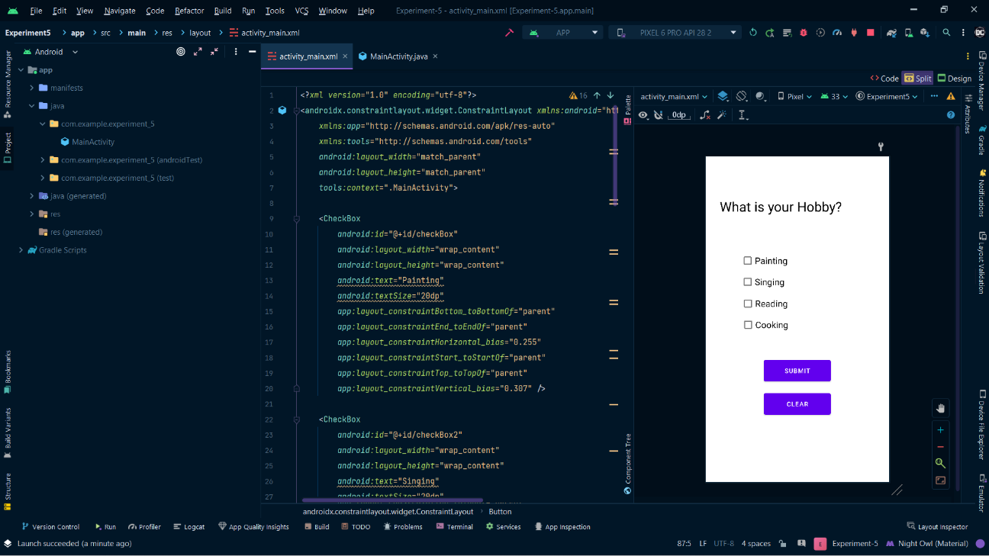

activity_main.xml (RadioButton)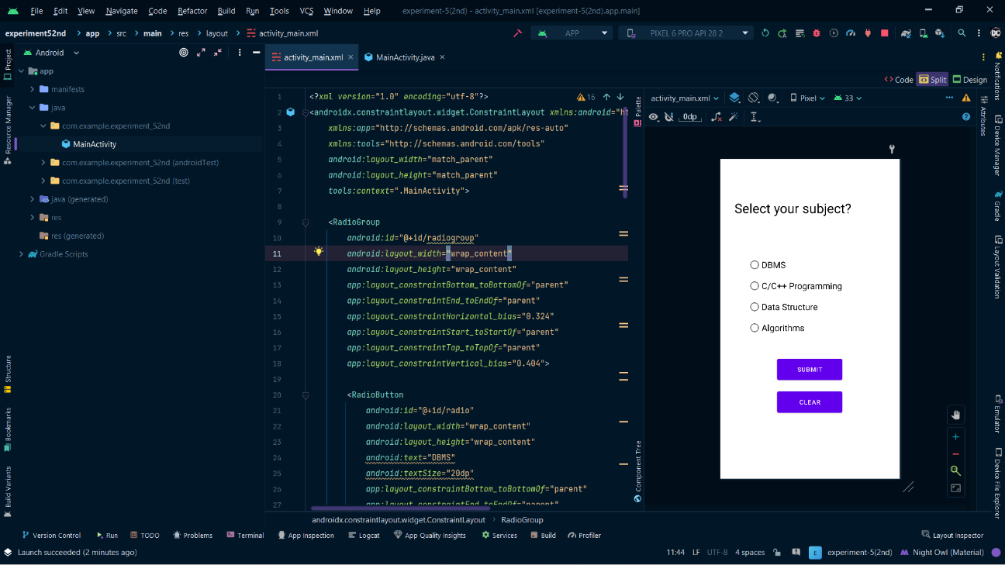

Output

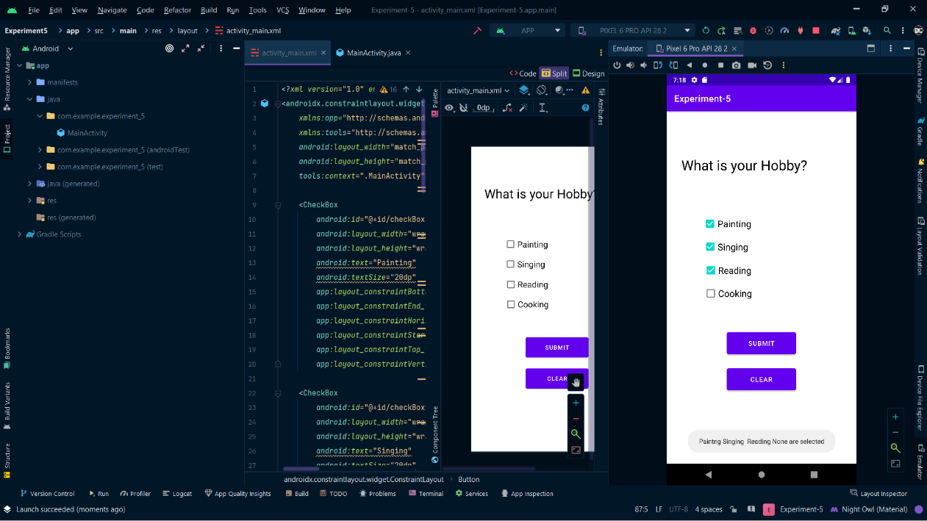 For CheckBox

When click on submit button, the output is shown below.

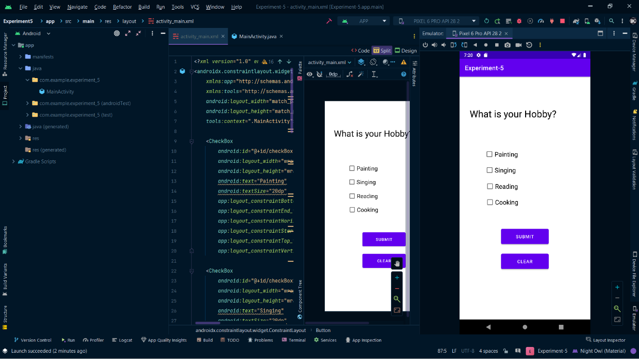When click on clear button, checkbox is cleared.

For RadioButton

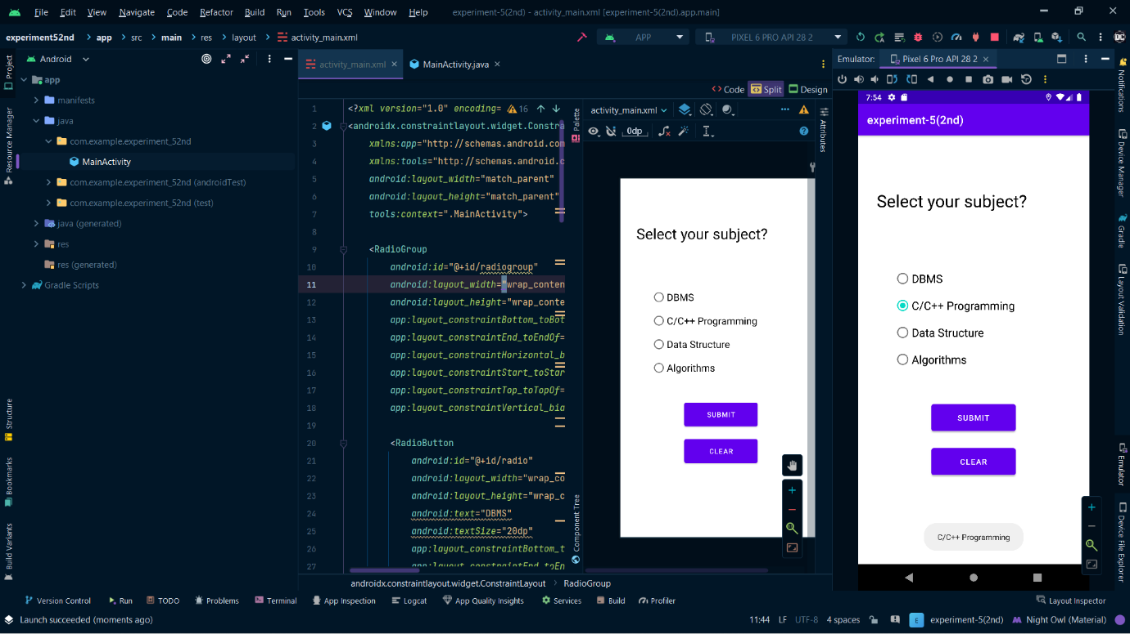When click on submit button, the output is shown below.

When click on clear button, checkbox is cleared.

